- photograph

(1 image)
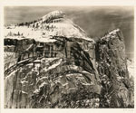
Yosemite Edward Weston 1940 2003.105.1
- poster

(1 image)
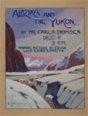
Alaska and the Yukon Edwards, H. Arden 1949 14.C.1131
- print

(1 image)
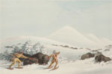
Buffalo Hunt, on Snow Shoes Catlin, George 1844 3023.G.1P
- tapestry

(1 image)
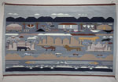
Diné (Navajo) 1970 - 1978 47.P.532
- catalog, trade

(1 image)
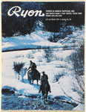
Catalog no. 58 Ryon Saddle and Ranch Supply Fall and Winter 1974 93.66.547
- crate label

(1 image)
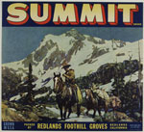
Summit Western Lithograph Company 1930s 91.170.416
- lantern slide

(1 image)
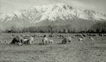
Frashers early to mid-1900s LS.2613
- lantern slide

(1 image)
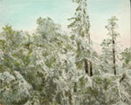
Maude, F. H. late 1800s to mid-1900s LS.13038
- lantern slide

(1 image)
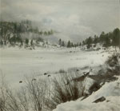
Maude, F. H. late 1800s to mid-1900s LS.13084
- lantern slide

(1 image)
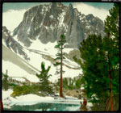
Maude, F. H. early 1900s LS.12694
- lantern slide

(1 image)
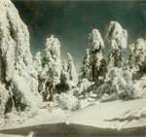
Pacific Stereopticon Co.; Maude, F. H.? early 1900s LS.13344

- lantern slide

(1 image)
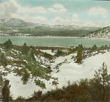
Maude, F. H. March 1937 LS.13064
- lantern slide

(1 image)
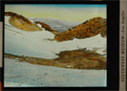
Unidentified Photographer late 1800s to early 1900s LS.3207
- photograph

(3 images)
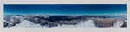
Mt. Dana Foster, Gus 1990 2002.66.1
- photograph

(1 image)
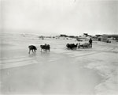
Harris, Gladys Knight 1949 P.53344

- photograph

(1 image)
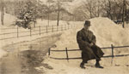
Skinner, Alanson B. circa 1900-1925 A.63.291
- postcard

(1 image)
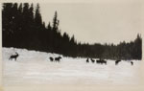
AZO 1930 91.210.126

