- capote

(1 image)
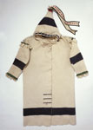
Blackfoot late 1800s - early 1900s 92.161.10
- coat

(1 image)
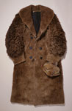
1870s 90.143.17

cap

(2 images)
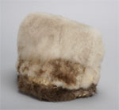
Arctic Indians 505.G.8

- moccasin boot

(2 images)
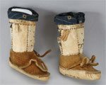
Arctic Indians 467.G.13AB
- pants

(3 images)
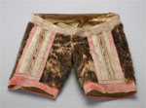
Arctic Indians circa 1925 505.G.2
- mittens

(1 image)
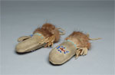
Kuskwogmiut Yup'ik 822.G.11

- card, cereal

(1 image)
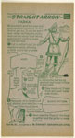
Parka National Biscuit Company 1952 94.18.1.16
- photograph

(2 images)
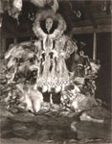
Harris, Gladys Knight 1949 P.52929

