- ball

(1 image)
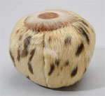
Inuit (cultural community) before 1949 2306.G.59
- doll

(2 images)
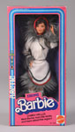
Eskimo Barbie Mattel, Inc. 1981 2009.87.1
- figurine

(1 image)
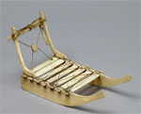
Arctic Indians before 1923 2161.G.16
- photograph

(1 image)
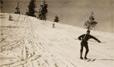
Unidentified Photographer early 1900s P.12653

photograph

(1 image)
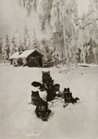
mid-1800s to mid-1900s 90.253.1600.2
- card, cereal

(1 image)
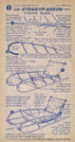
Indian Sled National Biscuit Company 1950 2004.16.2.34
- program

(1 image)
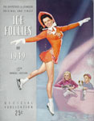
Shipstads & Johnson Ice Follies of 1949 1949 2005.47.5

- painting

(1 image)
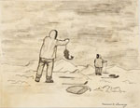
Chauncey, Florence Inuit (cultural community) before 1949 2306.G.432
- doll

(2 images)
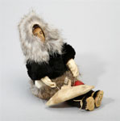
Arctic Indians before 1976 2124.G.9

- photograph

(1 image)
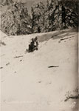
Kindig late 1800s P.14413

- snowshoe

(2 images)
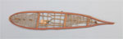
Athapaskan before 1964 1819.G.97
- brochure

(1 image)
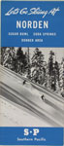
Let's Go Skiing at Norden, Sugar Bowl, Soda Springs, Donner Area Southern Pacific Company 1940 90.244.33

- program

(1 image)
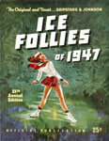
Shipstads & Johnson Ice Follies of 1947 1947 2005.47.4

