- box

(2 images)
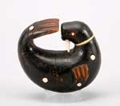
Yup'ik 1873 980.G.128

- figure, toy

(3 images)
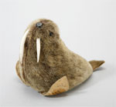
Arctic Indians before 1976 2124.G.12

- figurine

(1 image)
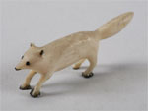
Arctic Indians circa 1900 1672.G.33B

figurine
(2 images)

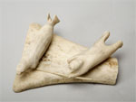
Salomonie Arctic Indians SW96.28.2A
- figurine
(1 image)
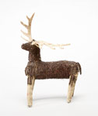
Oceti Sakowin (Seven Council Fires (Great Sioux Nation)) circa 1930 1574.G.31
- figurine

(1 image)
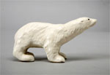
circa 1949 2306.G.407A

- brochure

(1 image)
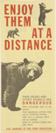
Enjoy Them at a Distance circa 1960 2003.22.7.5
- figurine

(2 images)
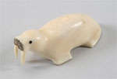
Inuit before 1955 1380.G.5
- figurine

(1 image)
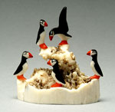
Hubert Kokuluk Inuit 2001 2004.29.12

- figurine

(1 image)
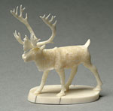
Leonard Savage Athapaskan 1991 2004.29.7
- pin

(1 image)
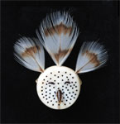
Snow Owl Mask McKay, Glenda Athapaskan 2008 2008.55.1
- figurine

(2 images)
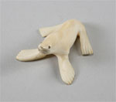
Yupik before 1961 1664.G.4

- figurine

(1 image)
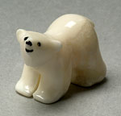
Inuit? (cultural community) 2001 2004.29.11
- crate label

(1 image)
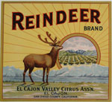
Reindeer Schmidt Lithograph Company 1920s 91.170.360

